**PYTHON SAMPLE PROGRAMS**

**By Harsh R Jain - 1BG17CS031**

**1. Write a Python Program to Add Two Numbers.**

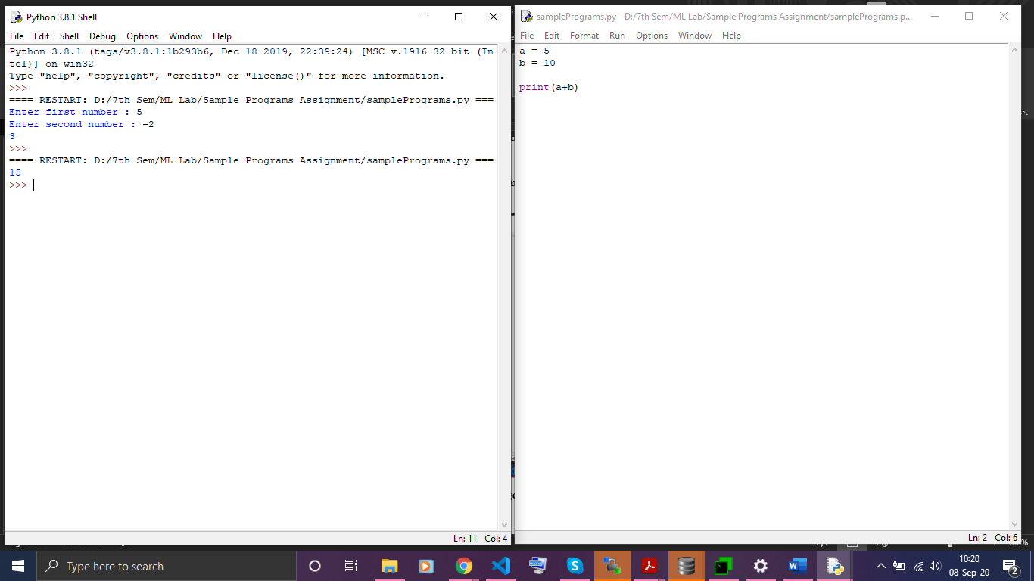

**2. Write a Python Program to Add Two Numbers Provided by The User.**

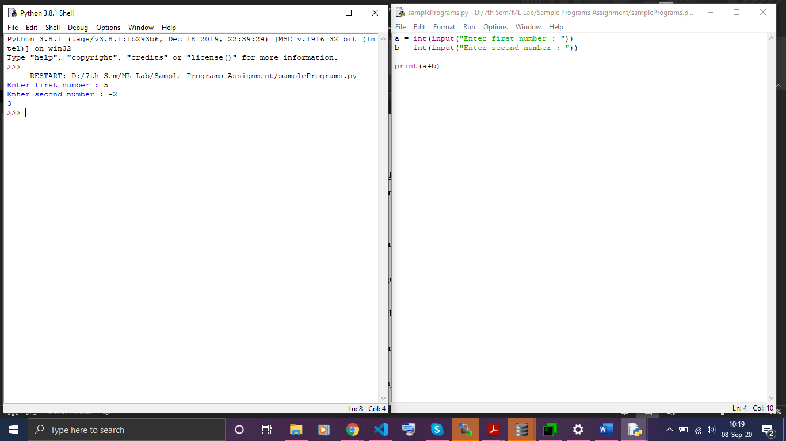

**3. Write a Python Program to Find the Largest Among Three Number.**

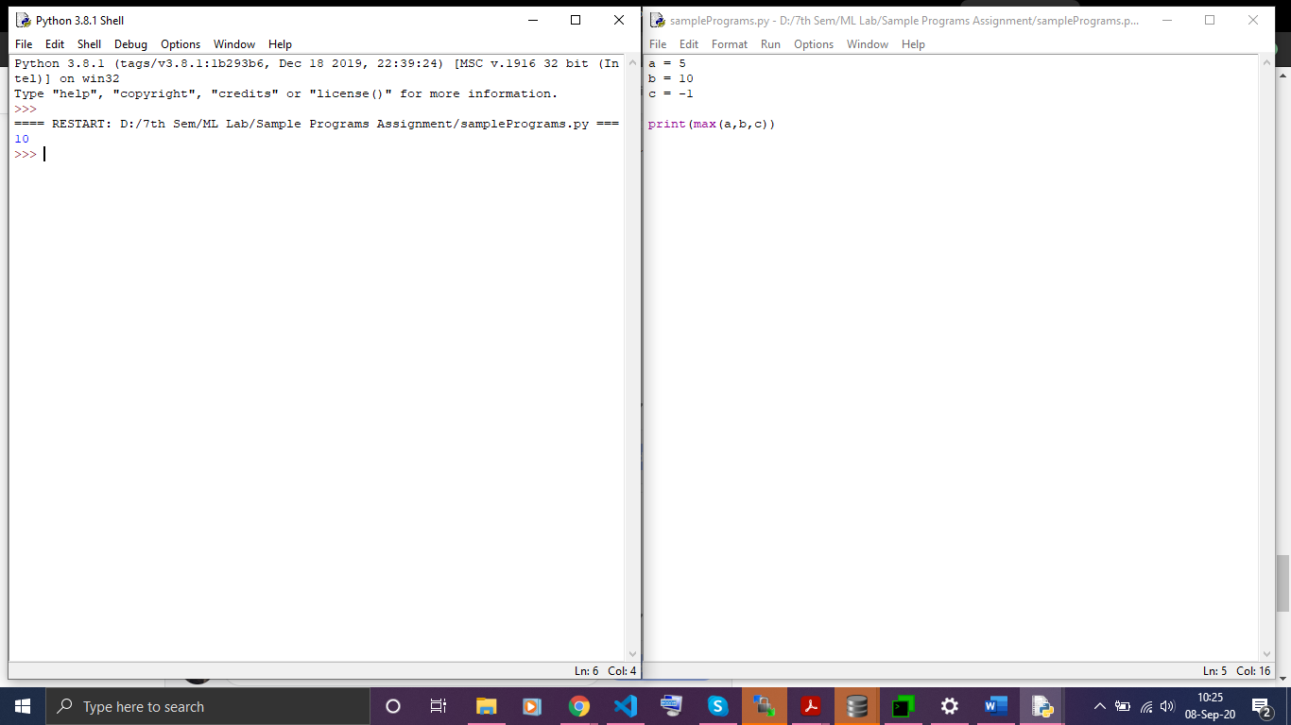

**4. Write a Python Program to find LCM without using GCD function.**

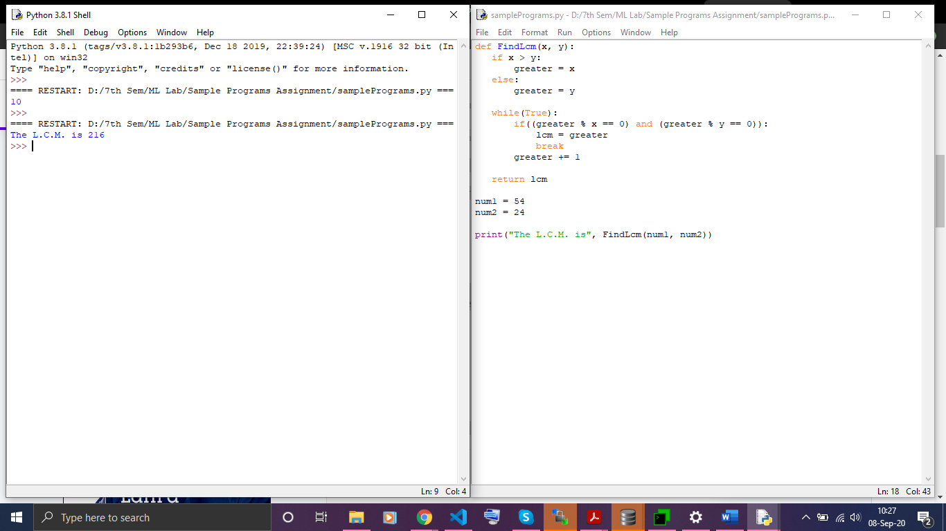

**5. Write a Python Program to find LCM using GCD function.**

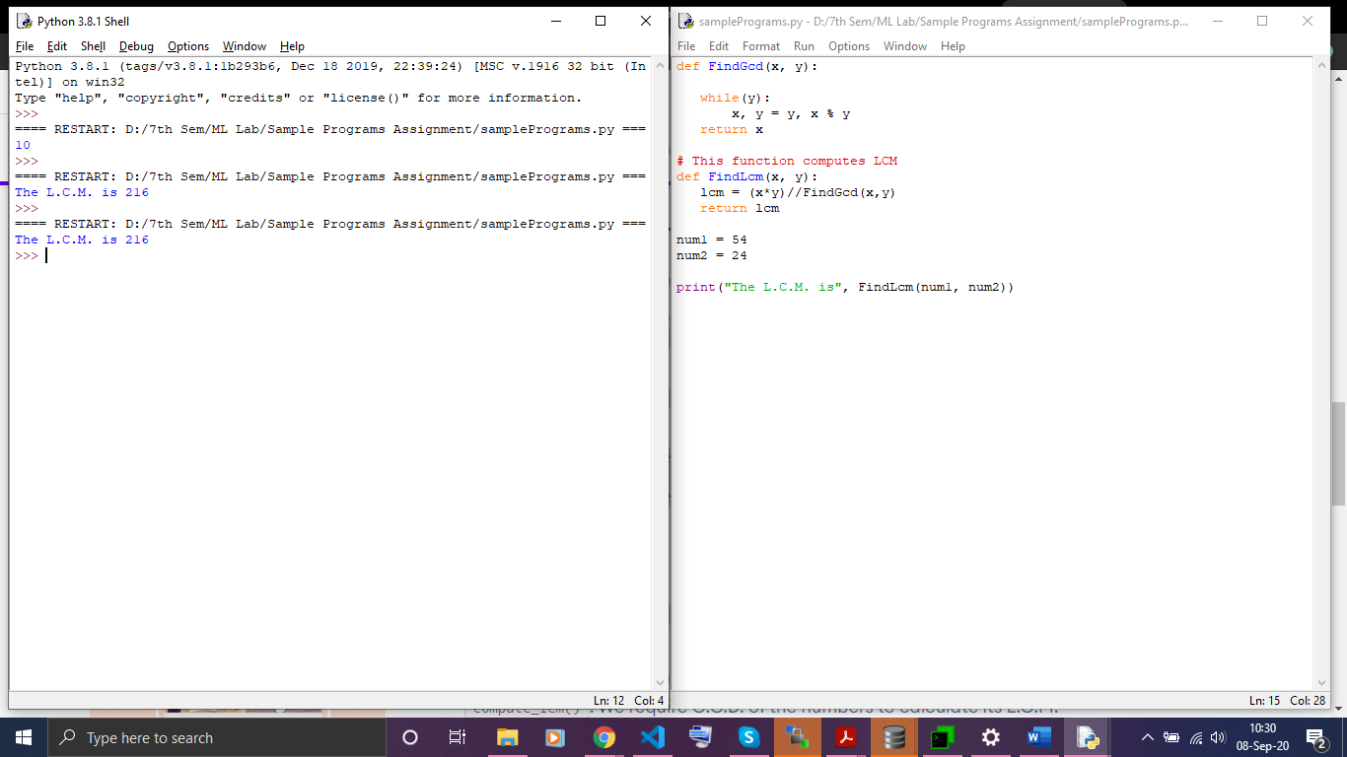

**6**.**Write a Python Program to simulate a** **Simple Calculator by making Functions**

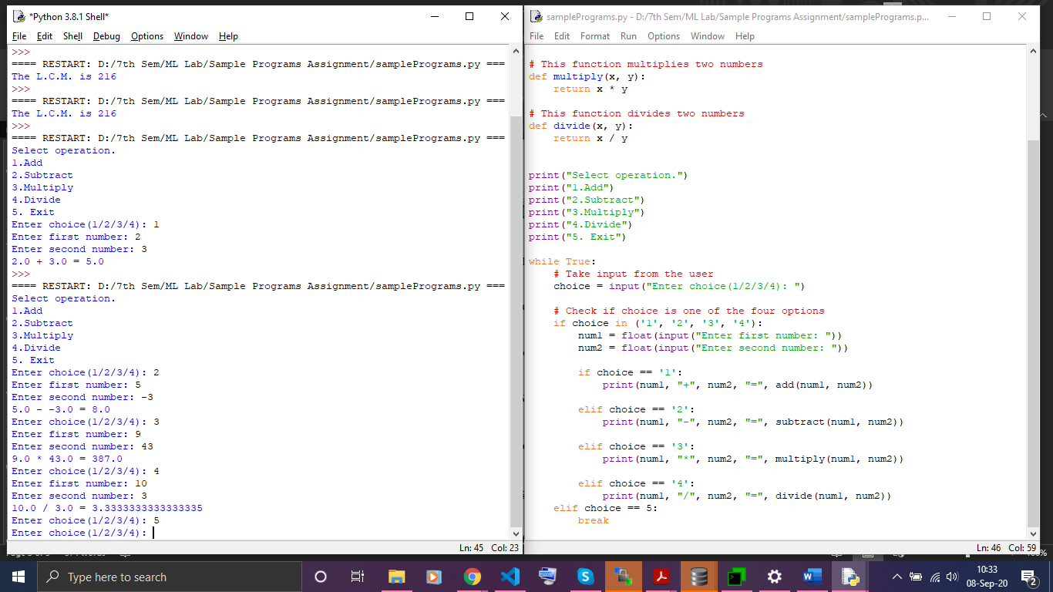

**7. Write a Python Program to Print all Prime Numbers in an Interval.**

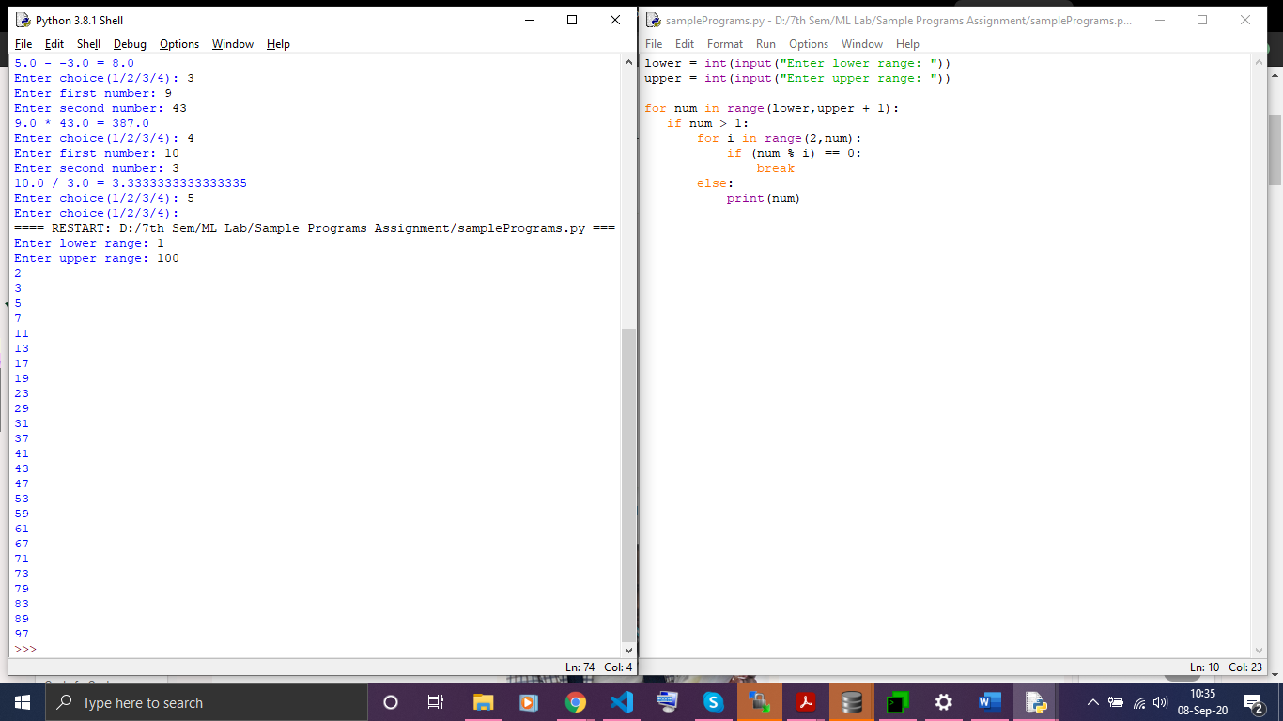

**8. Write a Python Program to Find the Sum of Natural Numbers.**

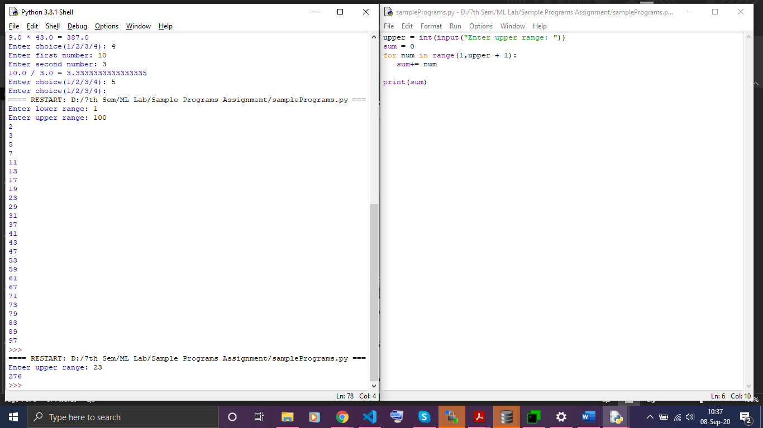

**9**. **Python Program to Find Sum of Natural Numbers Using Recursion.**

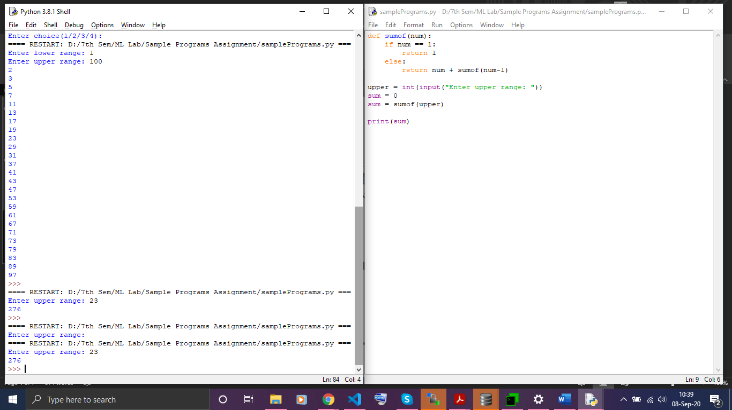

**10. Write a Python Program to Print the Fibonacci sequence.**

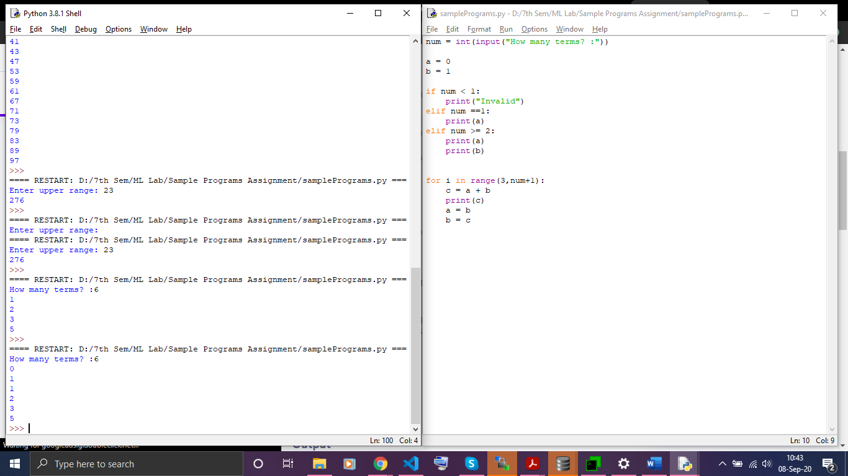

**11.Write a Python Program to create a string in Python.**

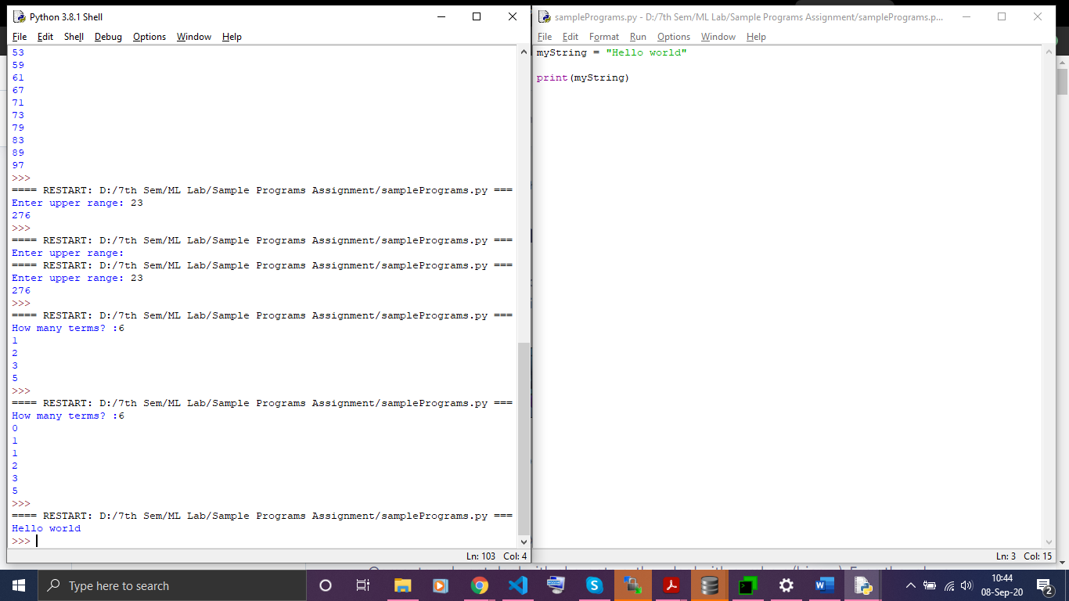

**12.Write a Python program to access characters in a String.**

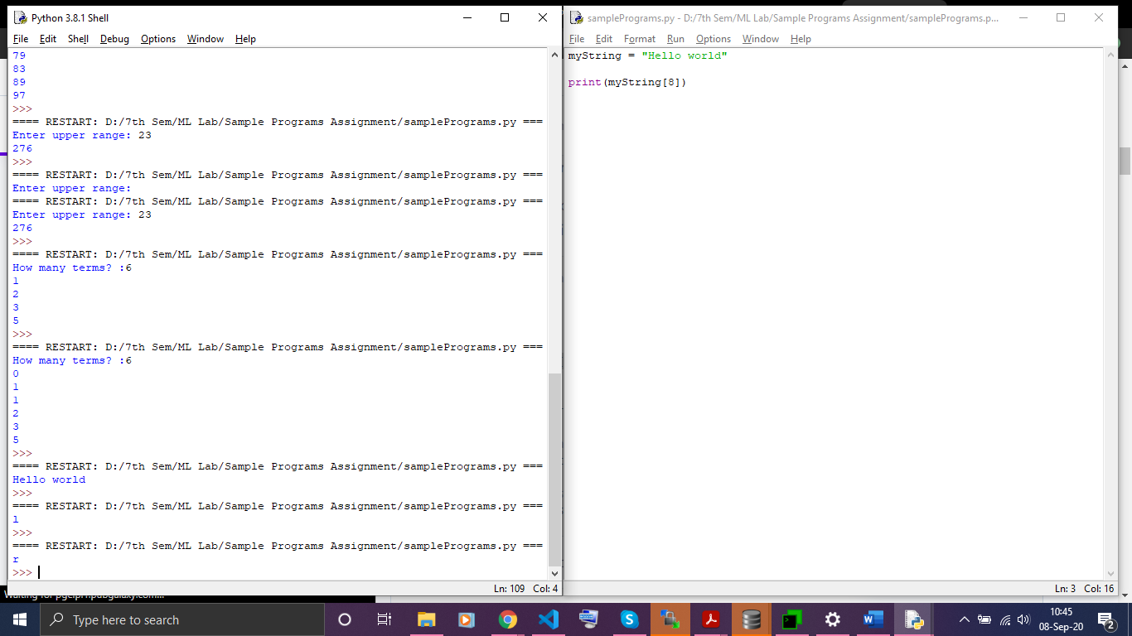

# **13.Write a Python program to count the number of characters (character frequency) in a string.**

# 

**14.Write a Python program to get a string made of the first 2 and the last 2 chars from a given a string. If the string length is less than 2, return instead of the empty string.**

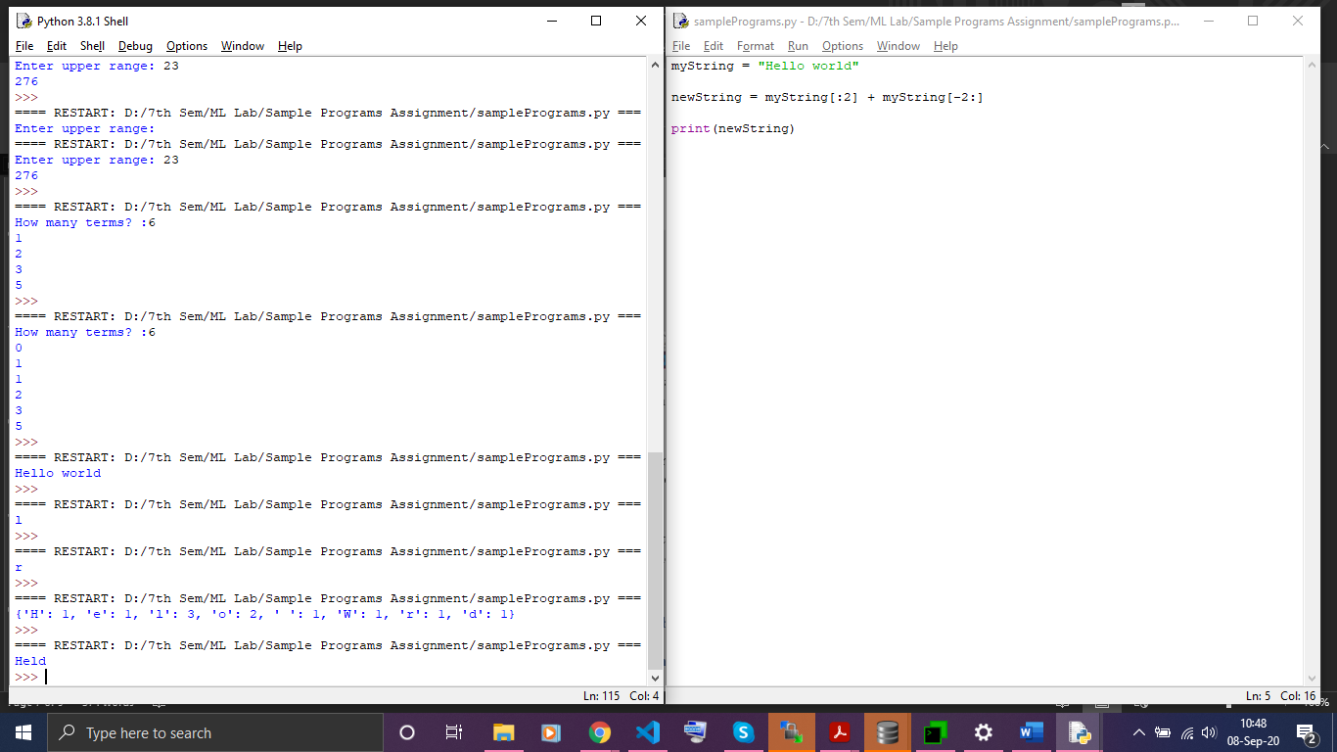

**15. Write a Python program to get a string from a given string where all occurrences of its first char have been changed to '$', except the first char itself.**

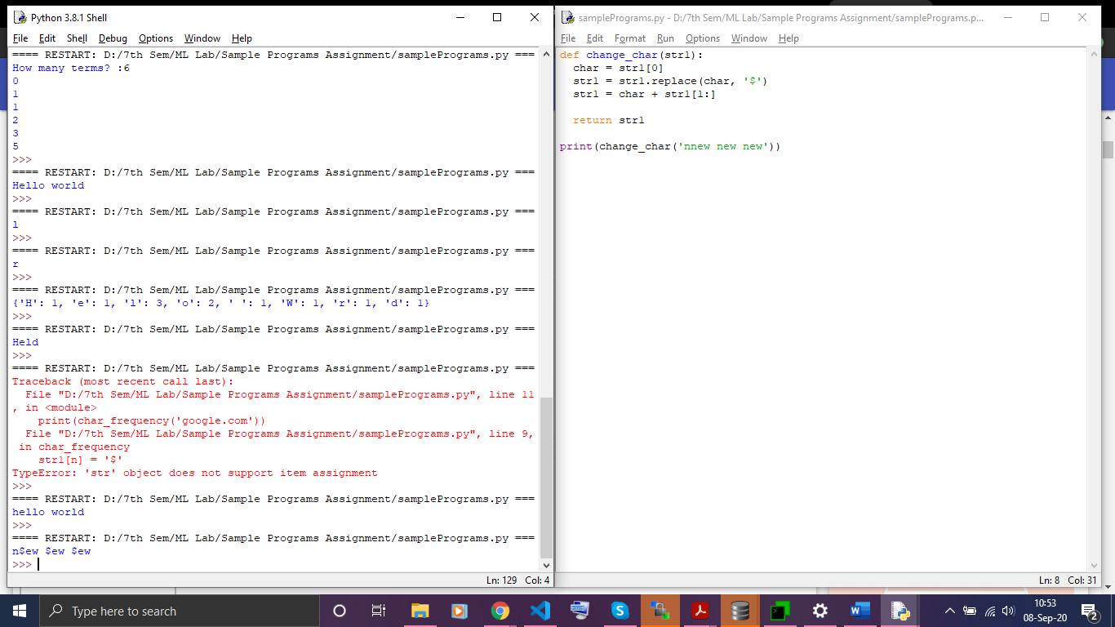

**16. Write a Python program to get a single string from two given strings, separated by a space and swap the first two characters of each string.**

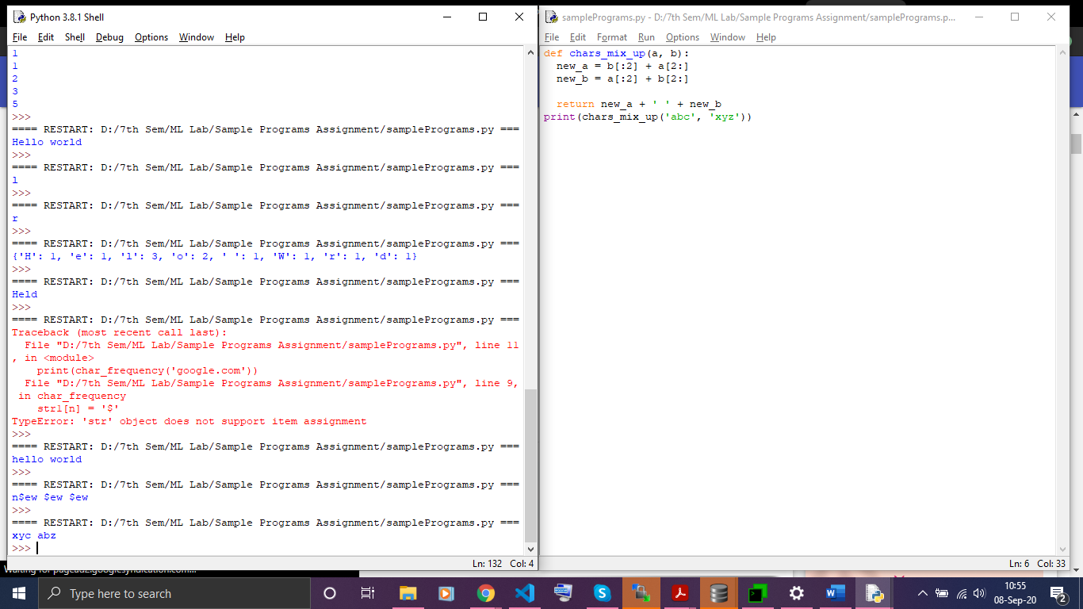

# **17. Write a Python program to add 'ing' at the end of a given string (length should be at least 3). If the given string already ends with 'ing' then add 'ly' instead. If the string length of the given string is less than 3, leave it unchanged**

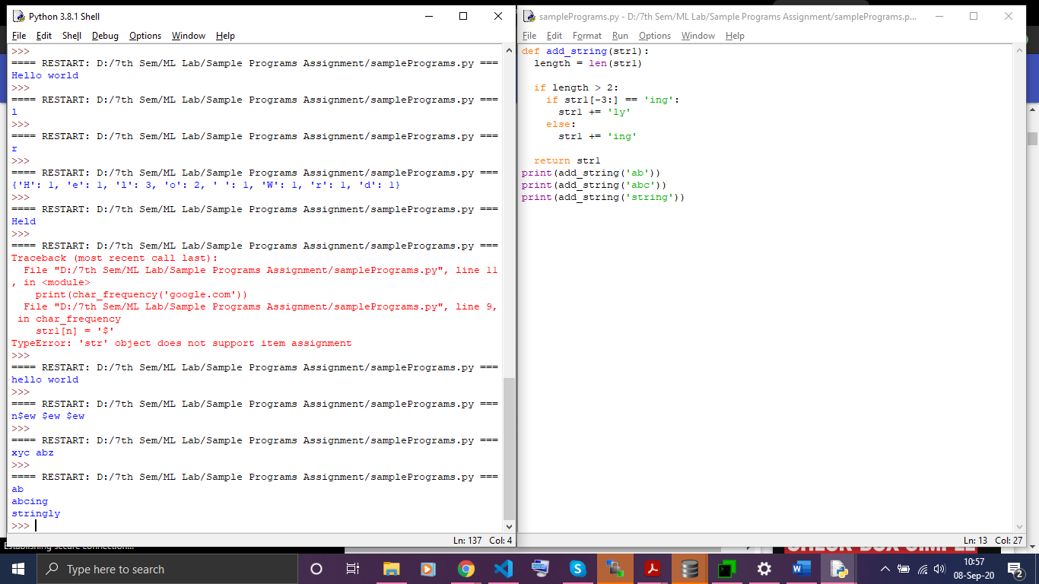

**18.Write a Python program to find the first appearance of the substring 'not' and 'poor' from a given string, if 'bad' follows the 'poor', replace the whole 'not'...'poor' substring with 'good'.**

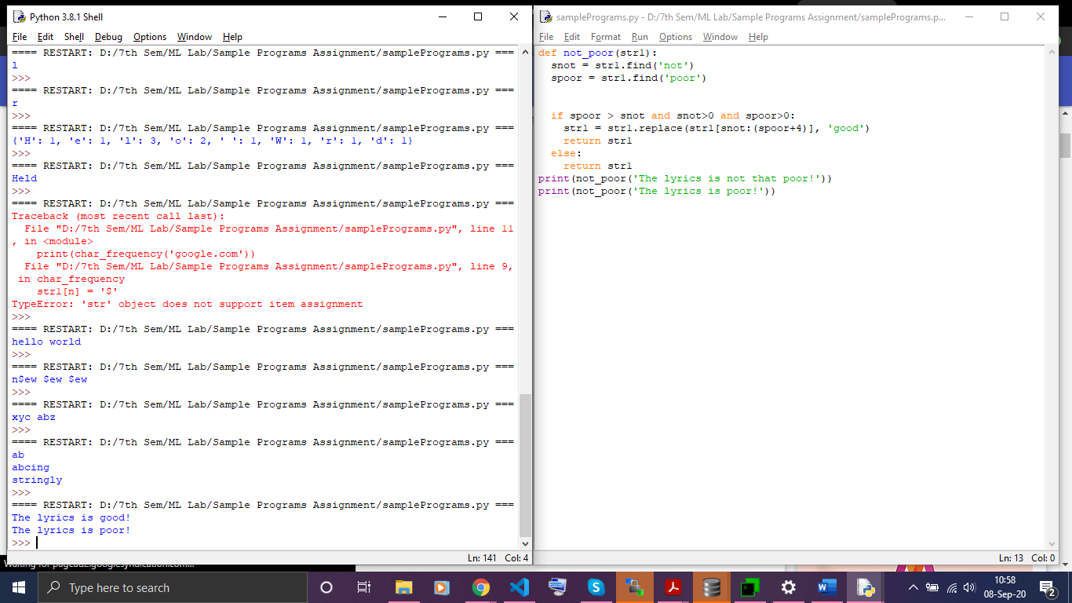

**19. Write a Python program to sum all the items in a list.**

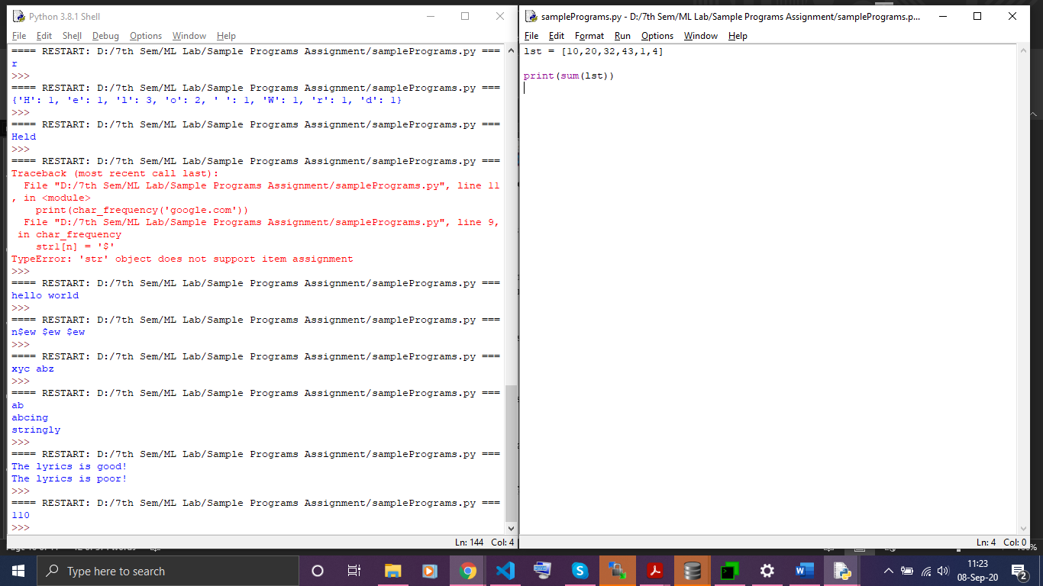

**20. Write a Python program to get the largest number from a list.**



**21. Write a Python program to count the number of strings where the string length is 2 or more and the first and last character are same from a given list of strings.**

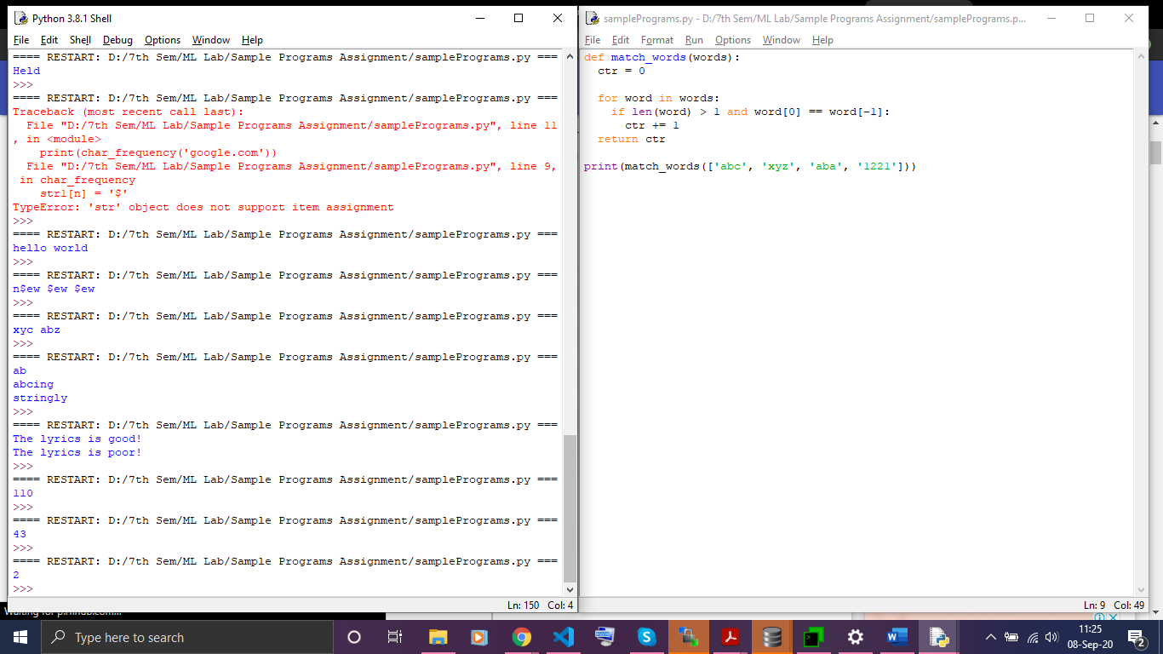

**22. Write a Python function that takes two lists and returns True if they have at least one common member.**

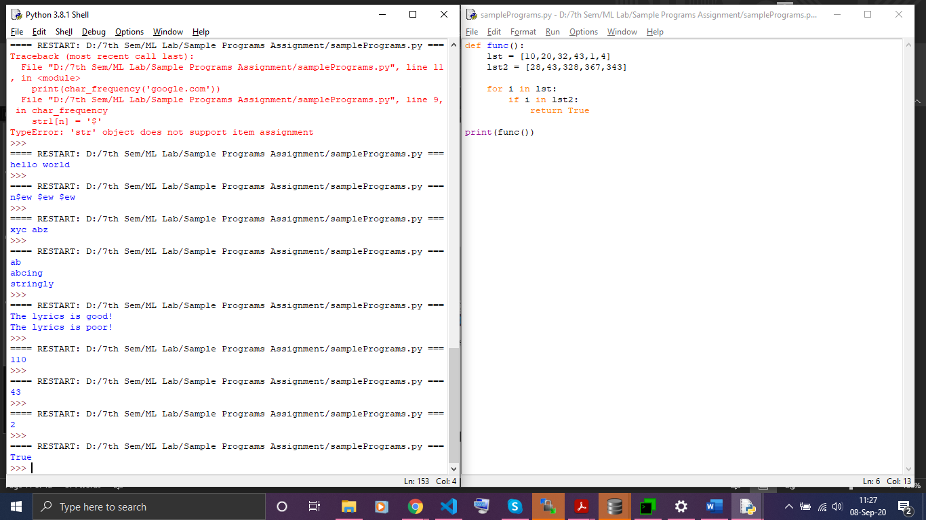

**23.Write a Python program to replace the last element in a list with another list**

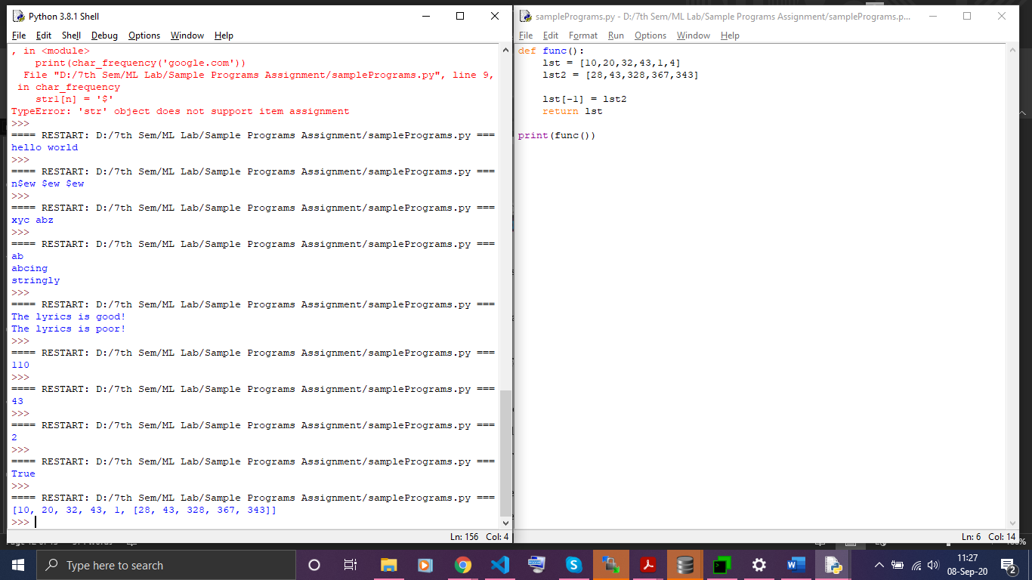

**24. Write a Python program to add a key to a dictionary.**

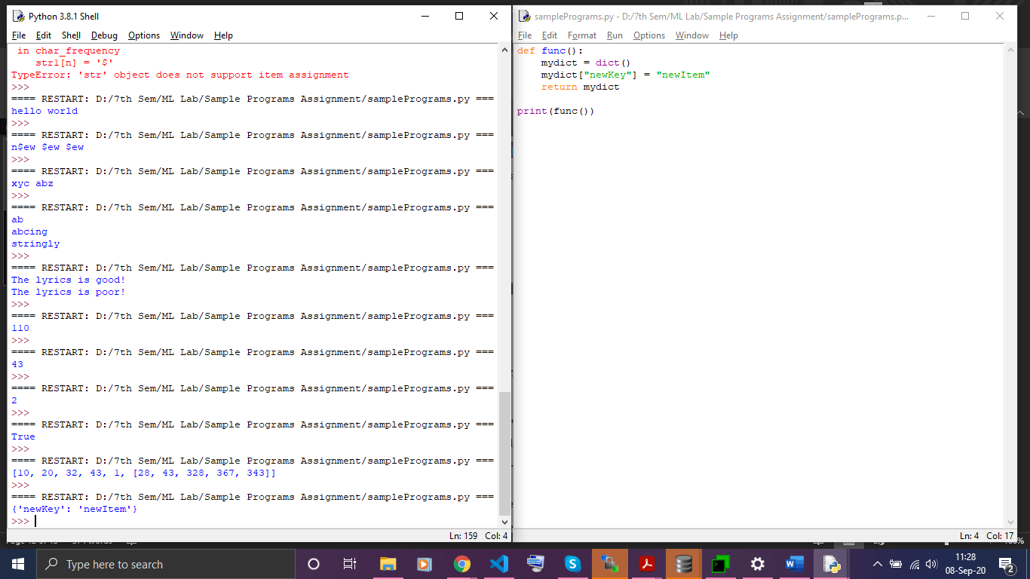

**25. Write a Python program to concatenate following dictionaries to create a new one.**

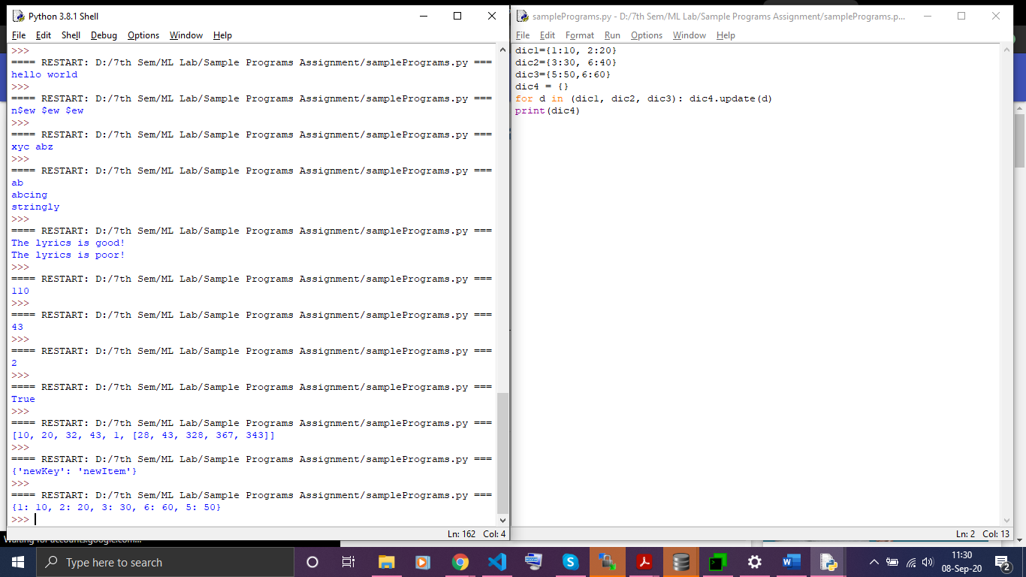

**26. Write a Python program to check if a given key already exists in a dictionary.**

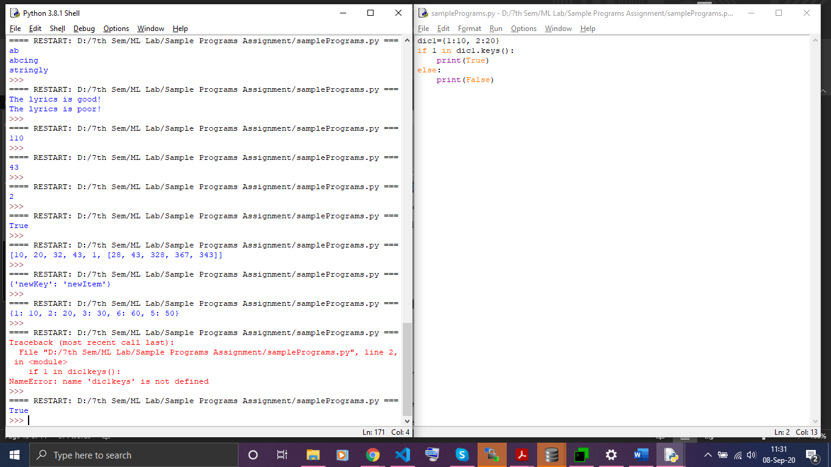

**27. Write a Python program to iterate over dictionaries using for loops.**

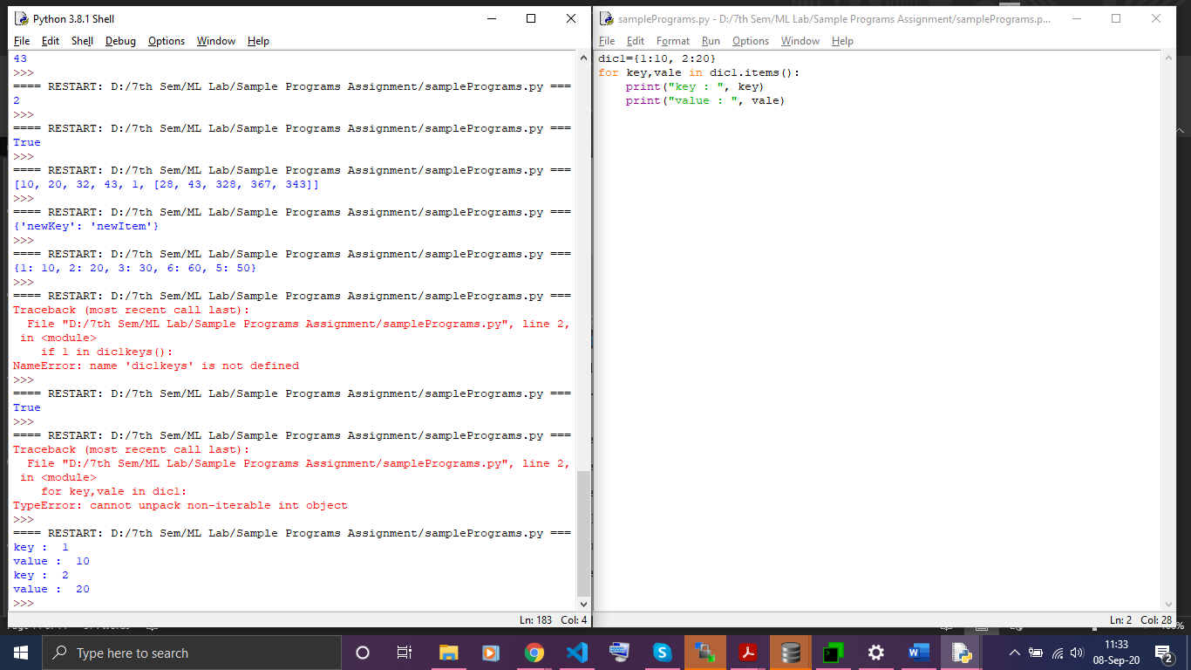

**28. Write a Python script to print a dictionary where the keys are numbers between 1 and 15 (both included) and the values are square of keys.**

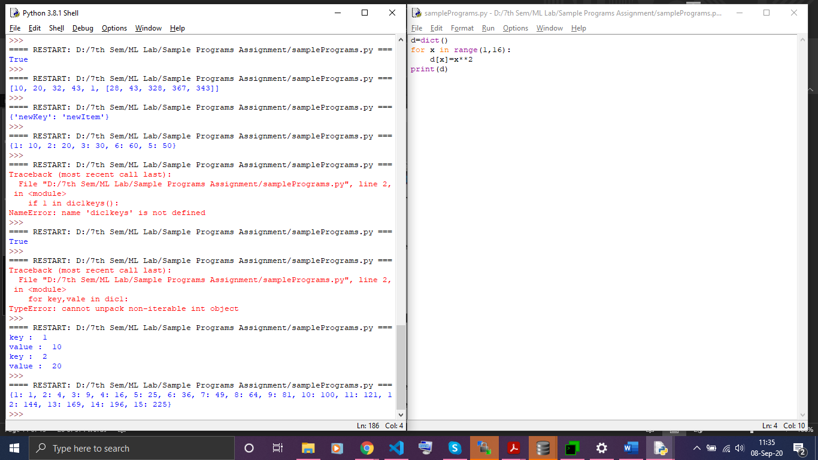

**29. Write a Python program to create a tuple.**

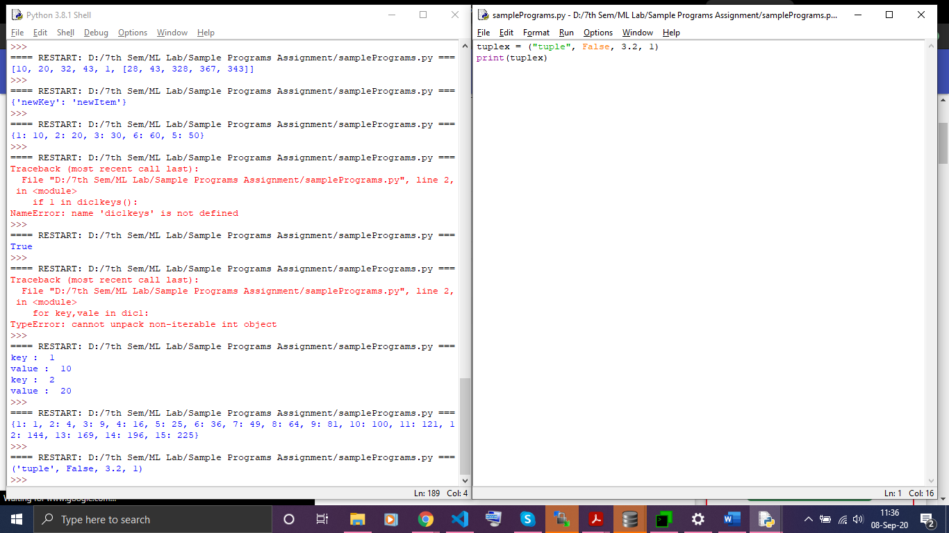

**30. Write a Python program to create a tuple with different data types.**



**31. Write a Python program to create a tuple with numbers and print one item.**

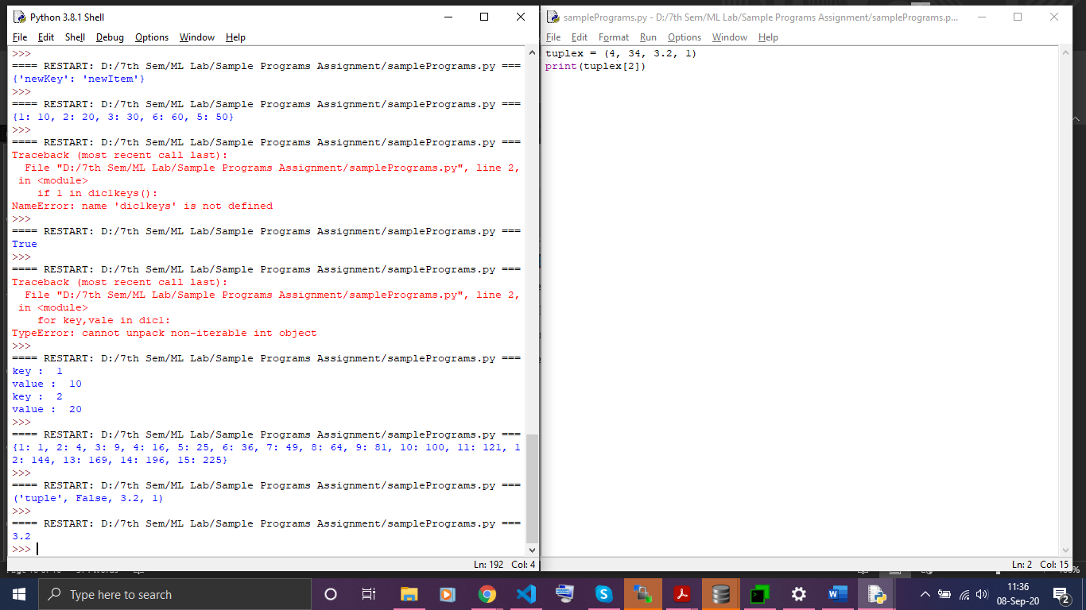

**32. Write a Python program to unpack a tuple in several variables.**

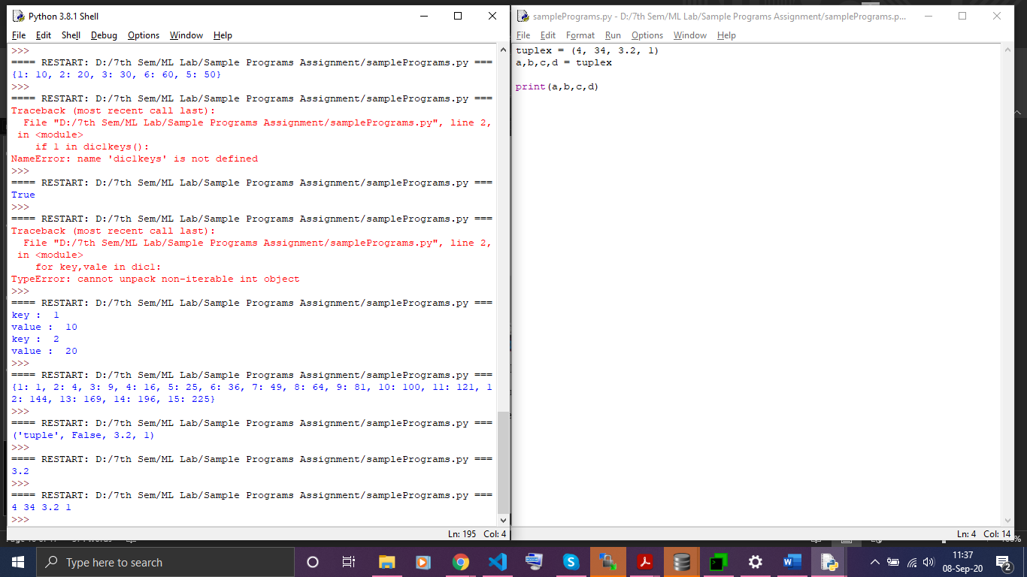

**33. Write a Python program to add an item in a tuple.**

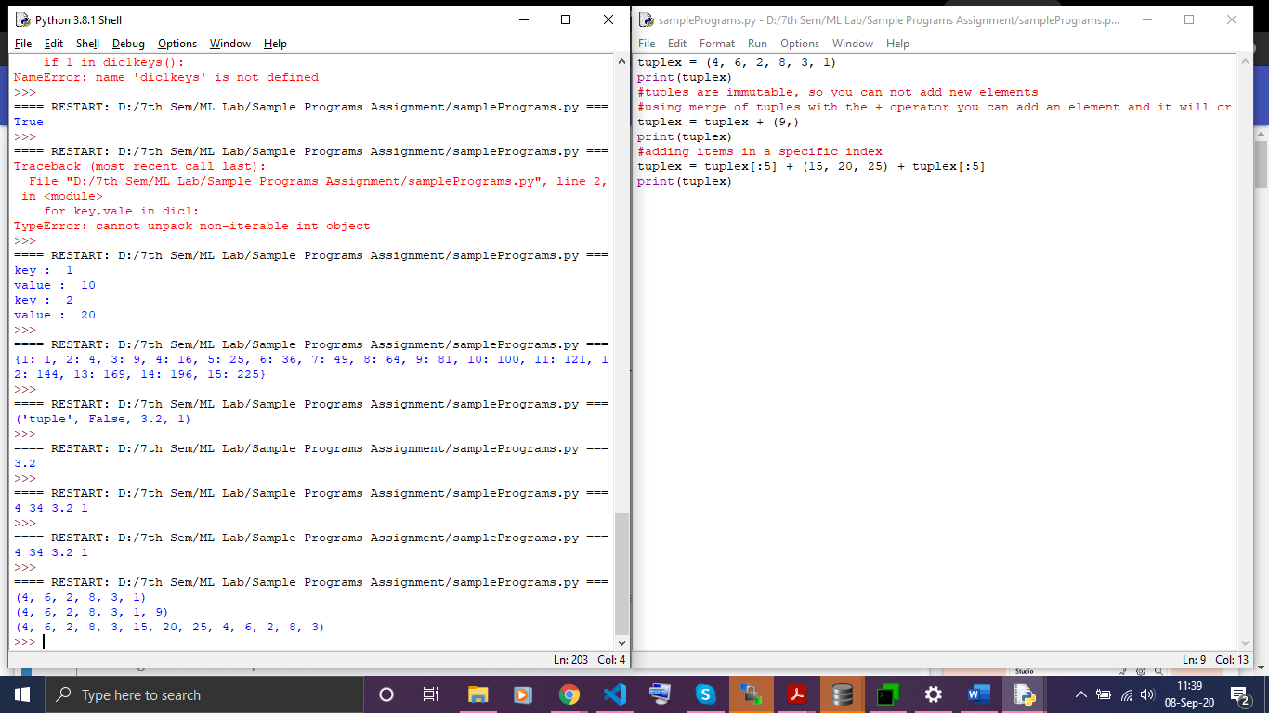

**34. Write a Python program to remove an item from a tuple.**



 